# Build a New VM for Power Shell Scripting

Select Virtual Machines

Select Add

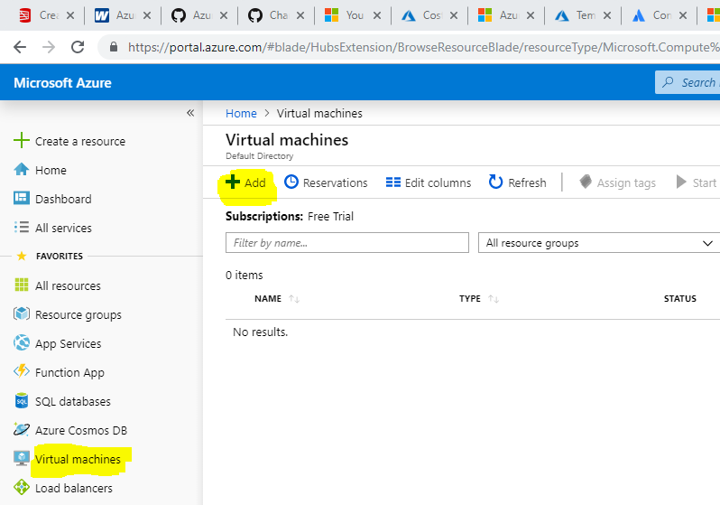

Basics

Select a resource group

Create a new one if this is a brand new installation – this may be advisable when creating a script that will be used by others to begin from scratch as this will then be included in the script

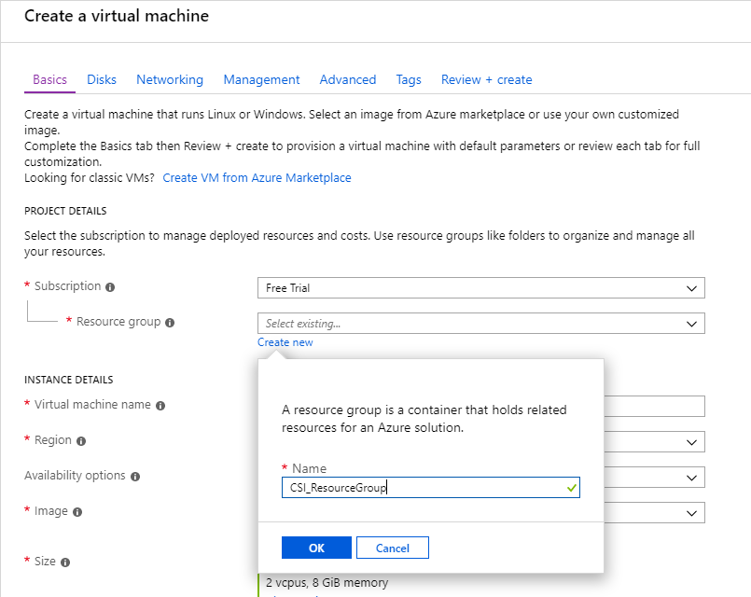

Give the VM a name

Select an image that is fit for purpose – a low power VM is used here for demonstration purposes

Add the admin account details

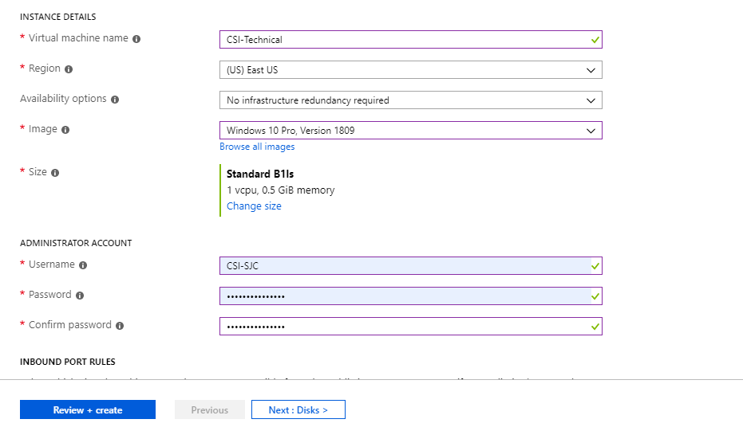

Allow any port communication that may be required e.g. RDP, HTTP, HTTPS

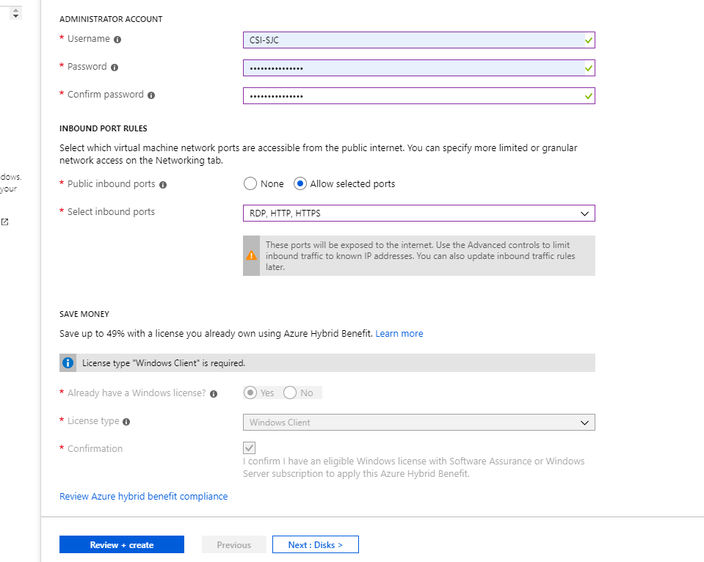

## Disks

Select an OS Disk Type suitable for your task

Decide on how to manage disks

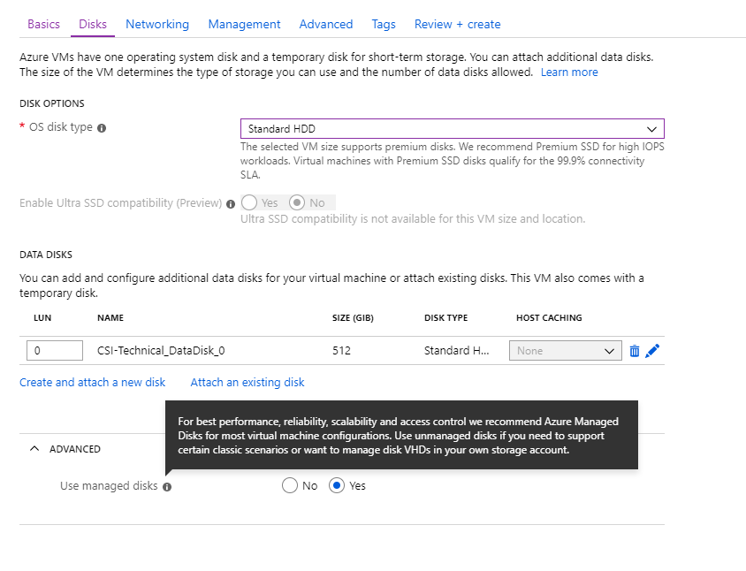

Add an optional data disk

* Select “Create and attach a new disk”
* Select the storage type suitable for your task
* Give it a name
* Select a size
* Select a source type – “None (empty disk)” may be most common

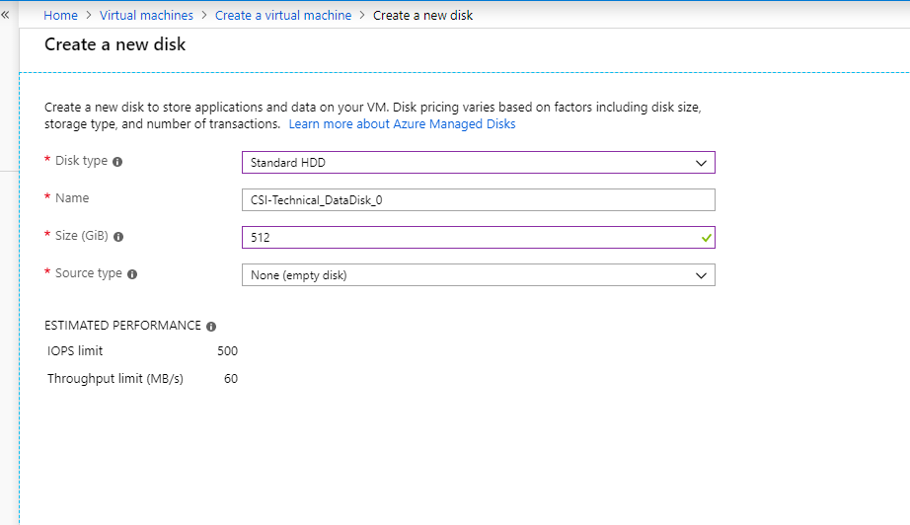

Networking

Practically all defaults can be accepted. A new virtual network will be created for you, as well as a new sub net.

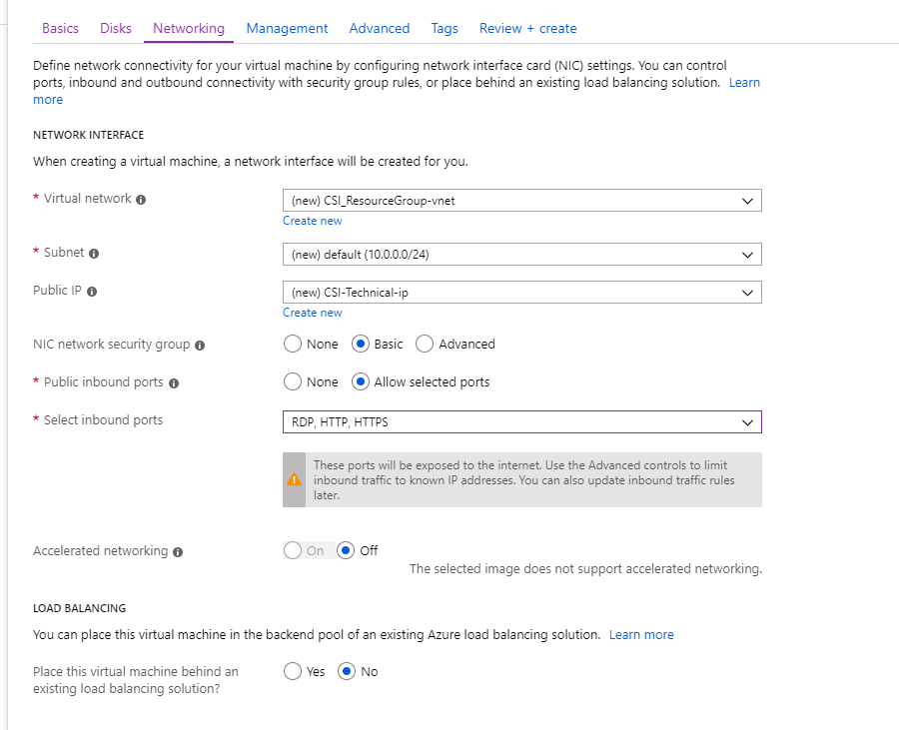

Management

Most default settings can be accepted, but auto-shutdown is advisable to reduce cost. Set a time when the team will not be affected by shutdown (this may preclude this option altogether if the server needs to be available 24/7)

Explicitly set the time zone to GMT

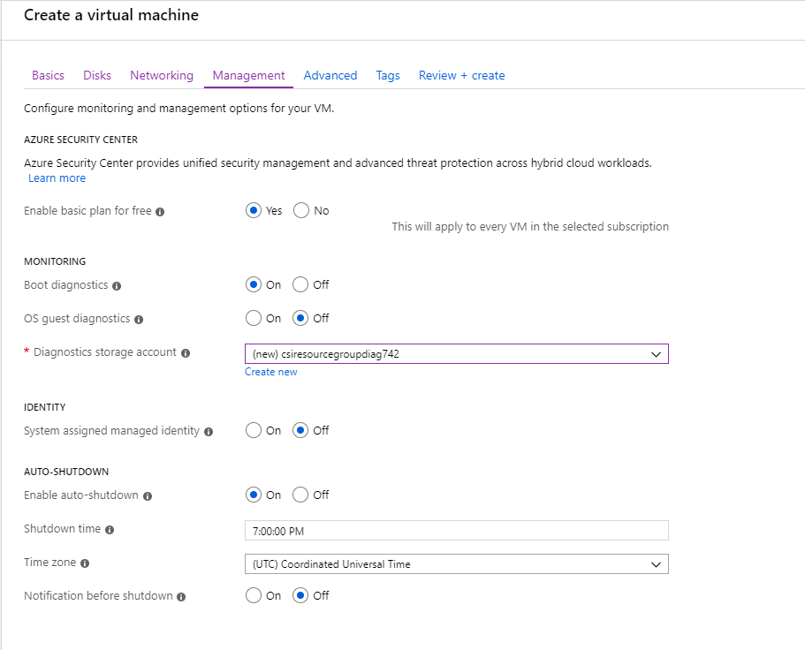

Advanced

* Nothing here

Tags

* Nothing here

Review and Create

This is where we need to download the template rather than select Create

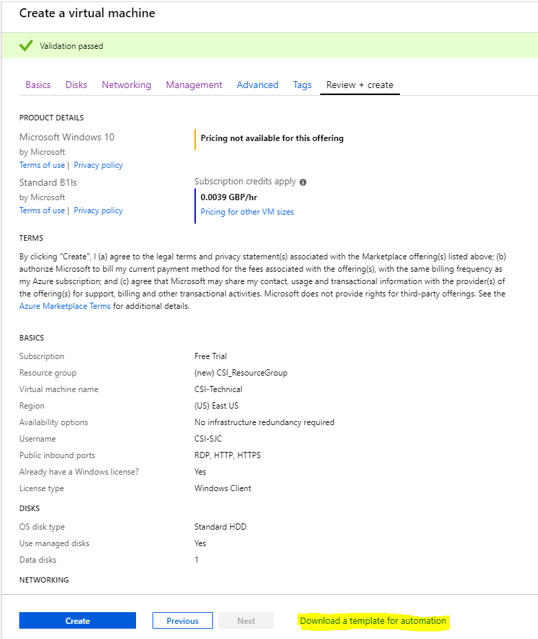

Select the download option

